Artist: Phal:Angst  Album: Shiver With Cold  Label: Bloodshed666 Records (bs13)  Distribution: Ordis (digital)  Release date: 14.11.2014 (original March 2009) | 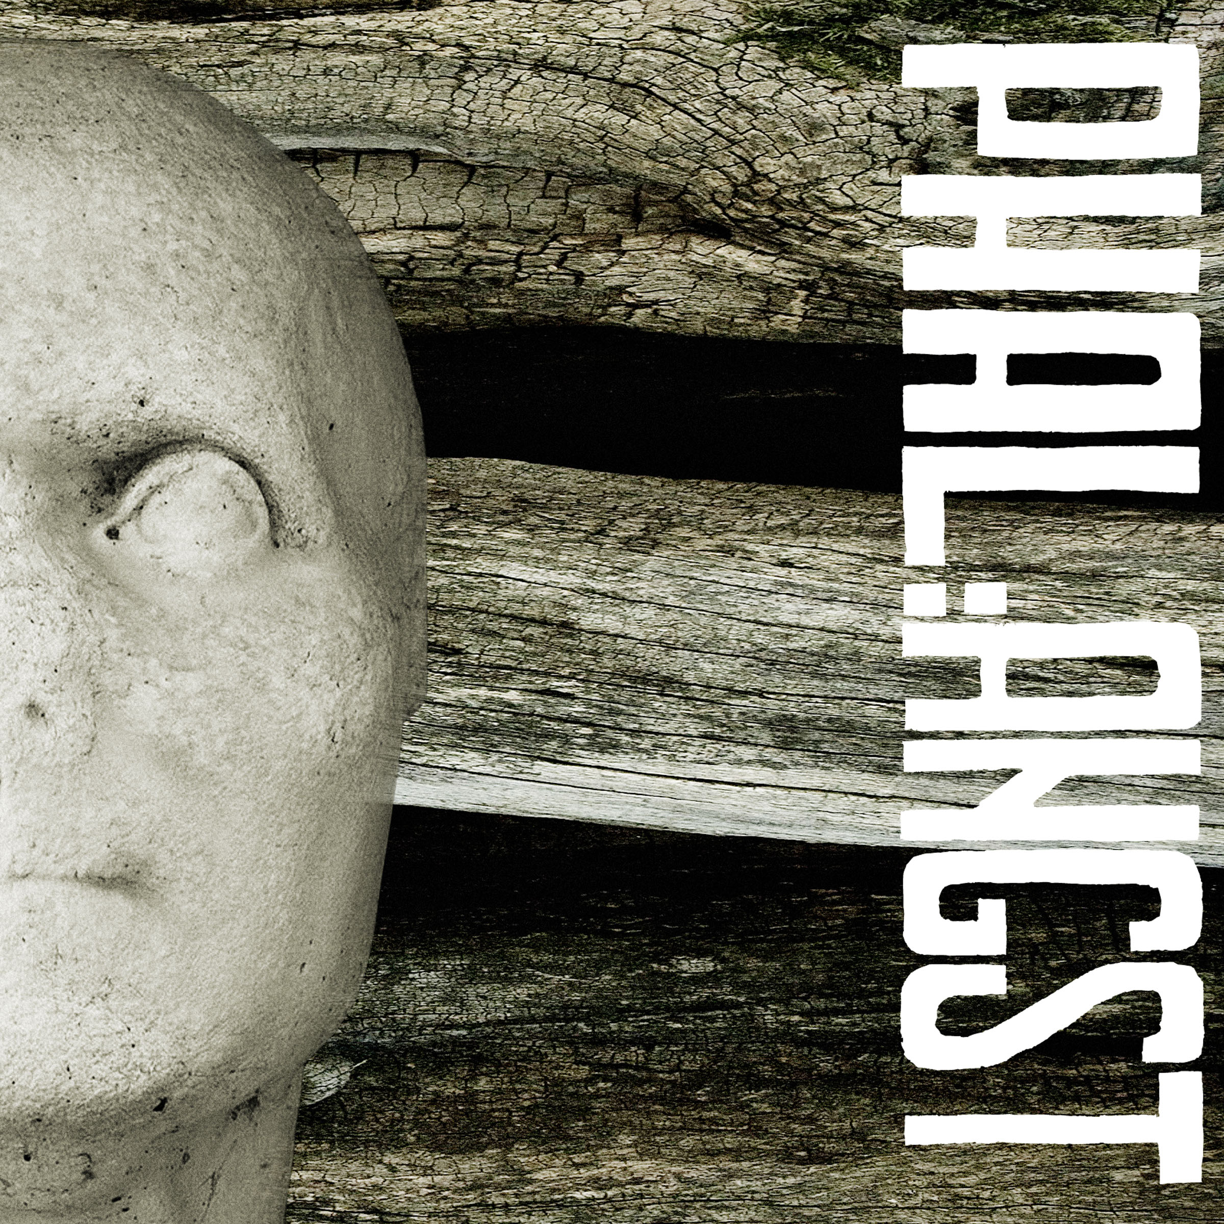

Tracklisting:
1. Hometown (09:38)
2. All Autumn’s Past (12:25)
3. Wasteland (9:05)
4. Despair (14:49)
5. Wasteland – Remix by Neon Squid Autopsy (06:23)

Phal:Angst is an Industrial/Post-Rock-Band from Vienna/Austria. They formed in 2006 and are about to release their third album in 2014. File between Industrial, EBM, Post-Rock and Doom and bands like Earth, Mogwai, Coil, Front 242 and Neurosis.

On their second album „Shiver With Cold“ (2009, digital rerelease 2014) the guitar approaches more and more the Post-Rock genre, electronics are intensified, beats are homemade and the songs pick up many motifs of the Saila soundtrack (2008).

Presssite: www.med-user.net/~bloodshed666/shiverwithcold

inform:
www.med-user.net/phalangst
www.facebook.com/phalangst

listen:
www.phalangst.bandcamp.com
www.soundcloud.com/phalangst
www.amazingtunes.com/phalangst

see:
www.youtube.com/bloodshed666records

label:
www.bloodshed666.net

PR: Alfred, indubiocontra@gmail.com, (+43) 650 834 5680

Phal:Angst – Black Country (2014, bs11, Cargo / Hoanzl / digital)
Industrial/EBM-influenced electronics are accompanied by guitar and vocals, where the latter increasingly explore realms of Pop. Synths and E-bass form a bass-heavy fundament, forcing the stereo to ventilate. Kaoss-Pad, harp & xylophone serve as additional phonetic elements, resulting in a cinematic dystopia set to push the boundaries of musical extremity.
"Black Country" was recorded by Alexandr Vatagin (Valeot Records, Slon, Tupolev, Port Royal, Werner Kitzmüller) and mastered by Austrian Techno pioneer Patrick Pulsinger. The stunning artwork was done by Christopher Sturmer (Stirn Prumzer, Atzgerei). "Black Country" will be released as a gorgeous Double Gatefold Vinyl, Digipack-CD and digitally.
At the same time the remix album "Black Country Revisited" (featuring remixes by Chra, Electric Indigo, David Pfister, Rokko Anal, Tronstoner, Swallowredrain and Bastard Sun) and the first two albums are going to be digitally (re)released.
Presssite: www.med-user.net/~bloodshed666/blackcountry

Phal:Angst – Black Country Revisited (2014, bs12, digital)
Seven artists did remixes of all tracks featured on „Black Country“. They were completely free to modify the songs as they wanted, resulting in a diversified album. Artists are: Electric Indigo, Chra, Tronstoner, Swallowredrain, David Pfister, Rokko Anal & Bastard Sun.
Presssite: www.med-user.net/~bloodshed666/blackcountryrevisited

Phal:Angst - для одной руки (2007, bs14, digital)
The first album from 2006. Gluey and doomy, based on highly slowed down breakbeats.
Presssite: www.med-user.net/~bloodshed666/dniaadnoiruki

